第8章-11章习题

- 设待排序数据的关键字为（3 26 67 35 9 -6 43 82 10 54）
以第一元素为枢轴元素进行快速排序。

4
split
split
5
split
7
split
9
split
3 26 67 35 9 -6 43 82 10 54
-6 3 67 35 9 26 43 82 10 54
-6
67 35 9 26 43 82 10 54
54 35 9 26 43 10 67 82
82
54 35 9 26 43 10
10 35 9 26 43 54
10 35 9 26 43
9 10 35 26 43
9
35 26 43
2
26 35 43
54
26
the number of total comparisons is 2+4+5+7+9=27

2、仿照下页对（3 26 67 35 9 -6 43 82 10 54）序列进行归并排序的递归树，画出对序列（512,275,908,677,503,765,612,897,170 ）
进行归并排序的递归树，并计算出总的比较次数。

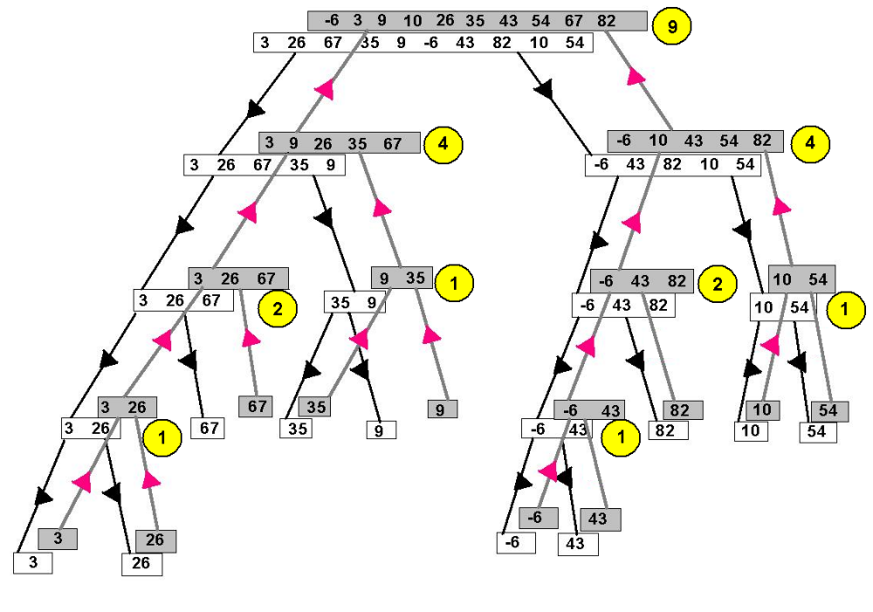
the number of total comparisons is :
1+1+1+1+2+2+4+4+9=25
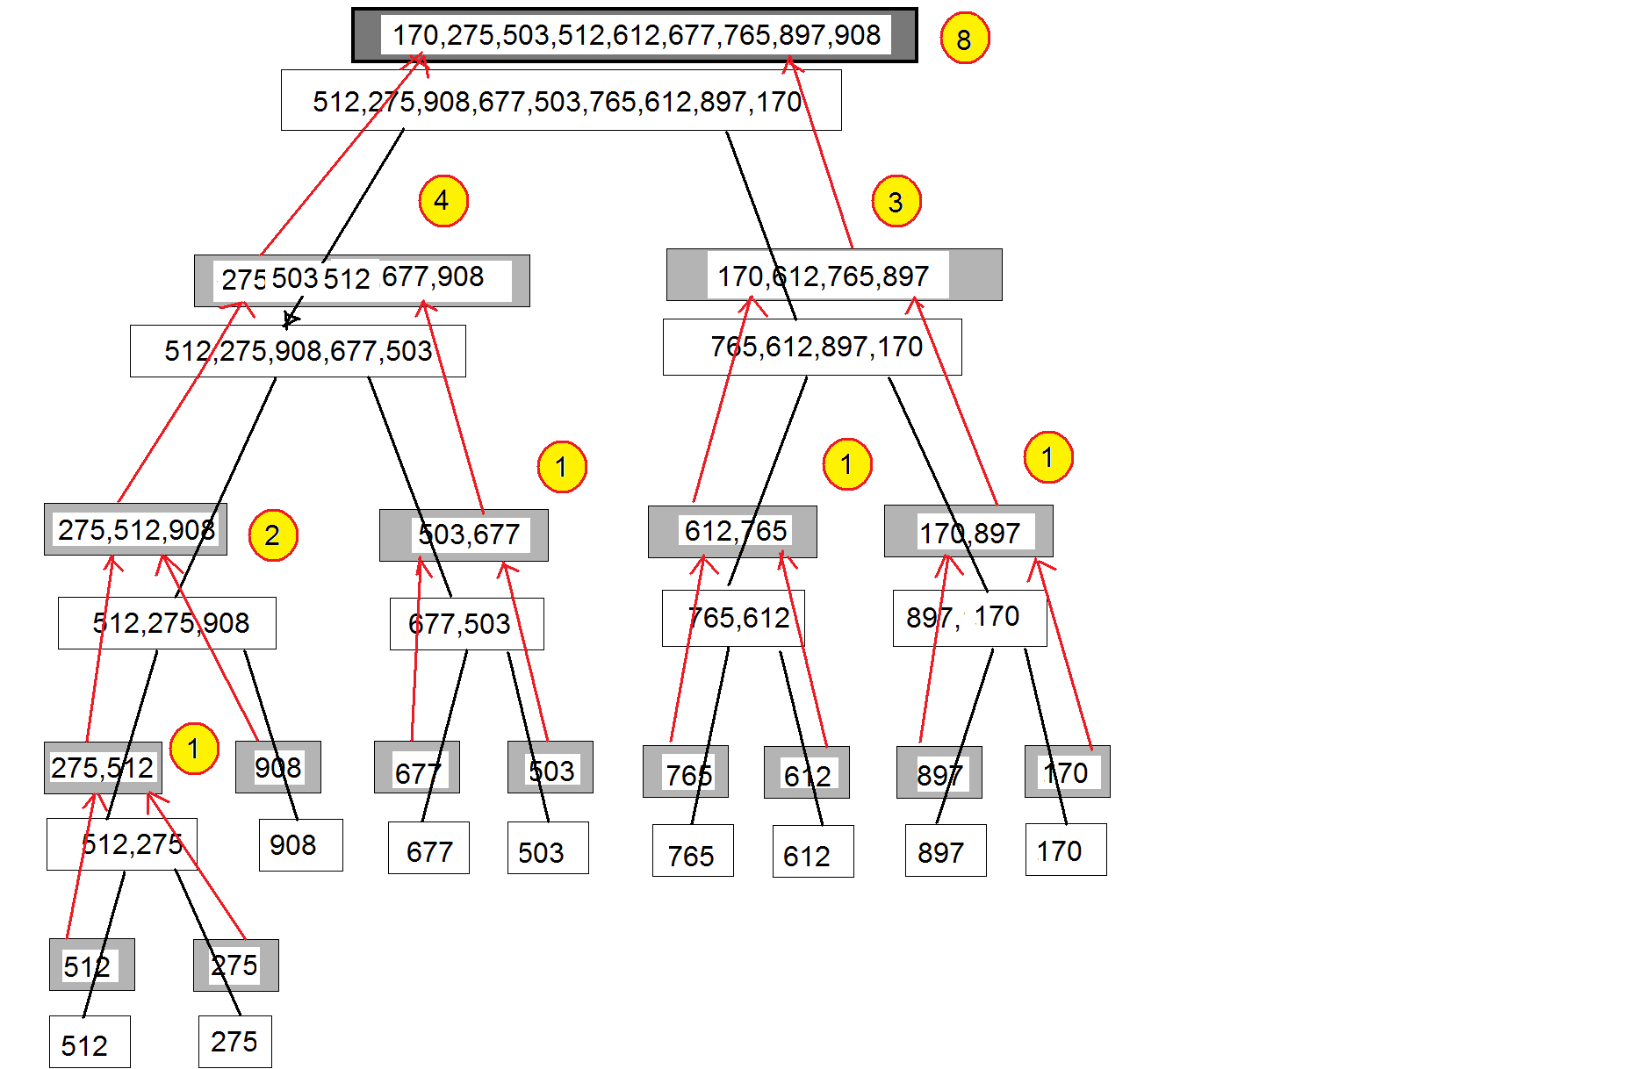

From the Mergesort tree, we can see that the number of total comparisons is :
1+1+1+1+2+3+4=21

2.(1) { 100, 86, 48, 73, 35, 39, 42, 57, 66, 21 }
1001
86
48
73
35
42
39
57
66
21

是大顶堆.

(2) { 12, 70, 33, 65, 24, 56, 48, 92, 86, 33 }
12
70
33
65
243
48
56
92
86
33

不是大顶堆
调整后的大顶堆为:
92
86
56
70
33
48
33
65
12
24

插入排序过程：
趟数 | 3 | 26 | 67 | 35 | 9 | -6 | 43 | 82 | 10 | 54 | 插入 | 比较次数
1 | 3 | 26 | 67 | 35 | 9 | -6 | 43 | 82 | 10 | 54 | 26 | 1
2 | 3 | 26 | 67 | 35 | 9 | -6 | 43 | 82 | 10 | 54 | 67 | 1
3 | 3 | 26 | 67 | 35 | 9 | -6 | 43 | 82 | 10 | 54 | 35 | 2
4 | 3 | 26 | 35 | 67 | 9 | -6 | 43 | 82 | 10 | 54 | 9 | 4
5 | 3 | 9 | 26 | 35 | 67 | -6 | 43 | 82 | 10 | 54 | -6 | 5
6 | -6 | 3 | 9 | 26 | 35 | 67 | 43 | 82 | 10 | 54 | 43 | 2
7 | -6 | 3 | 9 | 26 | 35 | 43 | 67 | 82 | 10 | 54 | 82 | 1
8 | -6 | 3 | 9 | 26 | 35 | 43 | 67 | 82 | 10 | 54 | 10 | 6
9 | -6 | 3 | 9 | 10 | 26 | 35 | 43 | 67 | 82 | 54 | 54 | 3
结果 | -6 | 3 | 9 | 10 | 26 | 35 | 43 | 54 | 67 | 82

彩色部分表示有序表部分,在有序表的基础上依次插入26至54共9个记录，共需比较次数为：1 + 1 + 2 + 4 + 5 + 2 + 1 + 6 + 3 = 25

算法：

判断二叉树是否为二叉查找树
template <class Entry>
bool Binary_tree<Entry> ::
recursive_IsSearchTree(Binary_node<Entry> *sub_root) const
{if (sub_root == NULL) return true;

if (sub_root->left)
if (sub_root->left->data>=sub_root->data)
return false;
if (sub_root->right)
if (sub_root->right->data<=sub_root->data)
return false;
return recursive_IsSearchTree (sub_root->left)
&&recursive_IsSearchTree (sub_root->right));

统计度为1的结点数

template <class Entry>
int Binary_tree<Entry> ::
recursive_degree1size(Binary_node<Entry> *sub_root) const
{if (sub_root == NULL ) return 0;
if (sub_root->left!=NULL && sub_root->right!=NULL)
return 1+
recursive_degree1size (sub_root->left)+
recursive_degree1size (sub_root->right));
else
return recursive_degree2size (sub_root->left)+
recursive_degree2size (sub_root->right));

删除叶子结点
template <class Entry>
void Binary_tree<Entry>:: recursive_deleteleaf(Binary_node<Entry>* &sub_root){
if(sub_root==NULL)
return;
if (sub_root->left==NULL && sub_root->right==NULL)
{delete sub_root;sub_root=NULL;return;}

recursive_deleteleaf(sub_root->left);
recursive_deleteleaf(sub_root->right);

}
template <class Entry>
void Binary_tree<Entry>:: deleteleaf()
{recursive_deleteleaf(root);
}

第10章 P 442 Exercise 10.1
E5 改为统计度为1的结点数
Answer
template <class Entry>
int Binary_tree<Entry>::countonechild()
{
return recursive_countonechild(root);
}

template <class Entry>
int Binary_tree<Entry>::recursive_countonechild (Binary_node<Entry> *sub_root)
{
int l,r;
if(sub_root ==NULL) return 0;
l=recursive_countonechild(sub_root ->left);
r=recursive_countonechild(sub_root ->right);
if ((sub_root ->left!=NULL &&
sub_root ->right==NULL) ||
(sub_root ->left==NULL
&& sub_root ->right!=NULL))
return l+r+1;
else
return l+r;

}

二叉树中找出最大值
Answer
template<class Entry>
void Binary_tree<Entry>:: findmax(Entry &max)
{recursive_findmax(root,max);
}
template<class Entry>
void Binary_tree<Entry>::recursive_findmax(Binary_node<Entry>* sub_root,Entry &max)
{if(subTree!=NULL)
{
if (sub_root ->data > max) max= sub_root ->data;
recursive_findmax(sub_root ->left,max);
recursive_findmax(sub_root ->right,max);
}
}

删除叶子结点
Answer
template <class Entry>
void Binary_tree<Entry>:: deleteleaf(){
recursive_deleteleaf(root);
}
template <class Entry>
void Binary_tree<Entry>:: recursive_deleteleaf(Binary_node<Entry>* &subTree){
if(subTree==NULL)
return;
if (subTree->left==NULL && subTree->right==NULL){
delete subTree;subTree=NULL;return;
}
recursive_deleteleaf(subTree->left);
recursive_deleteleaf(subTree->right);
}

E7. Write a method and the corresponding recursive function to insert an Entry, passed as a parameter, into a linked binary tree. If the root is empty, the new entry should be inserted into the root, otherwise it Binary_tree insert
should be inserted into the shorter of the two subtrees of the root (or into the left subtree if both subtrees have the same height).
Answer
template <class Entry>
void Binary_tree<Entry> :: insert(const Entry &x)
{
recursive_insert(root, x);
}
template <class Entry>
void Binary_tree<Entry> :: recursive_insert(Binary_node<Entry> * &sub_root,
const Entry &x)
{
if (sub_root == NULL) sub_root = new Binary_node<Entry>(x);
else
if (recursive_height(sub_root->right) < recursive_height(sub_root->left))
recursive_insert(sub_root->right, x);
else
recursive_insert(sub_root->left, x);
}

E10. Write a overloaded binary tree assignment operator.
Answer template <class Entry>
Binary_tree<Entry> :: operator= (const Binary_tree<Entry> &original)
{
Binary_node<Entry> *newroot = recursive_copy(original.root);
clear();
root=newroot;
}
template <class Entry>
Binary_node<Entry> *Binary_tree<Entry> :: recursive_copy(
Binary_node<Entry> *sub_root)
{
if (sub_root == NULL) return NULL;
Binary_node<Entry> *temp = new Binary_node<Entry>(sub_root->data);
temp->left = recursive_copy(sub_root->left);
temp->right = recursive_copy(sub_root->right);
return temp;
}

E11. Write a function to perform a double-order traversal of a binary tree, meaning that at each node of the tree, the function ﬁrst visits the node, then traverses its left subtree (in double order), then visits the node double-order traversal again, then traverses its right subtree (in double order).
Answer
template <class Entry>
void Binary_tree<Entry> :: double_traverse(void (*visit)(Entry &))
{
recursive_double_traverse(root, visit);
}
template <class Entry>
void Binary_tree<Entry> :: recursive_double_traverse
(Binary_node<Entry> *sub_root, void (*visit)(Entry &))
{
if (sub_root != NULL) {
(*visit)(sub_root->data);
recursive_double_traverse(sub_root->left, visit);
(*visit)(sub_root->data);
recursive_double_traverse(sub_root->right, visit);
}
}

E15. Write a function that will traverse a binary tree level by level. That is, the root is visited ﬁrst, then the immediate children of the root, then the grandchildren of the root, and so on. [Hint: Use a queue to keep level-by-level traversal track of the children of a node until it is time to visit them. The nodes in the ﬁrst tree of Figure 10.7 are numbered in level-by-level ordering.]
Answer In this solution, we assume that an implementation of a template class Queue with our standard Queue methods is available.
Answer
template <class Entry>
void Binary_tree<Entry> :: level_traverse(void (*visit)(Entry &))
{
Binary_node<Entry> *sub_root;
if (root != NULL) {
Queue < Binary_node<Entry> * > waiting_nodes;
waiting_nodes.append(root);
do {
waiting_nodes.retrieve(sub_root);
(*visit)(sub_root->data);
if (sub_root->left) waiting_nodes.append(sub_root->left);
if (sub_root->right) waiting_nodes.append(sub_root->right);
waiting_nodes.serve( );
} while (!waiting_nodes.empty( ));
}
}

E4. Draw the binary search trees that function insert will construct for the list of 14 names presented in each of the following orders and inserted into a previously empty binary search tree.
创建二叉查找树
- Jan Jon Tim Ron Guy Ann Jim
Tom Amy Eva Roy Kim Dot Kay

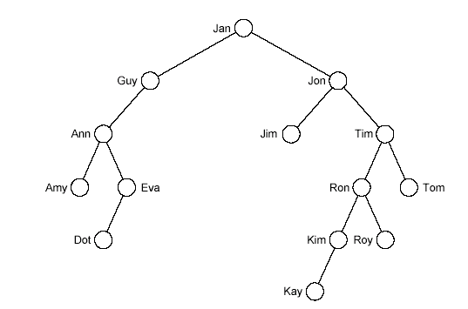

已知一棵二叉树的中序序列和后序序列分别为
BDCEAFHG和DECBHGFA，
画出这棵二叉树。

二叉树转成森林（树）
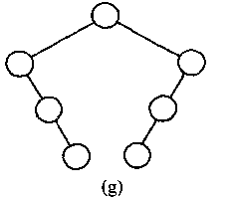 | 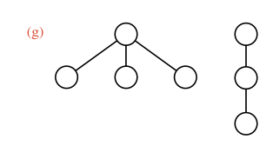
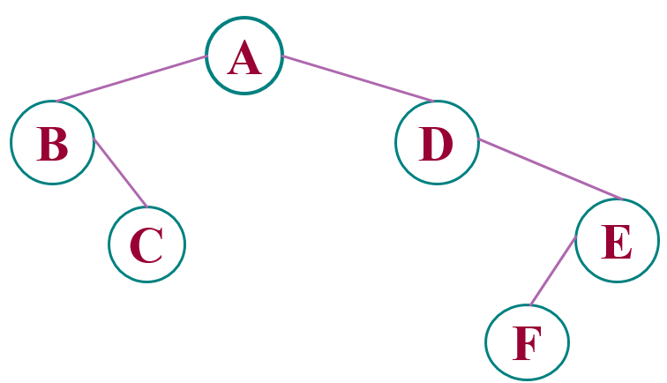
树转成二叉树
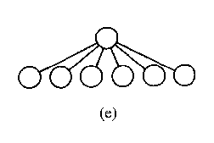 | 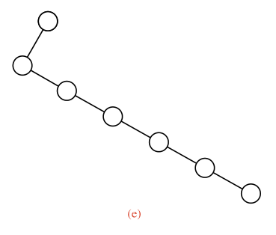
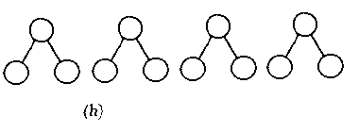 | 